Oracle19c安装文档

1.增加环境变量处理

vi /etc/profile.d/oracle19c.sh

source /etc/profile.d/oracle19c.sh

增加内容为:

export ORACLE_HOME=/opt/oracle/product/19c/dbhome_1

export PATH=$PATH:/opt/oracle/product/19c/dbhome_1/bin

export ORACLE_SID=ORA19C

2.关闭系统防火墙

systemctl stop firewalld //关闭防火墙

systemctl disable firewalld //禁止开机启动

3.关闭selinux

vi /etc/selinux/config

SELINUX=disabled

source /etc/selinux/config

4.创建用户组及用户

groupadd oinstall

groupadd dba

useradd oracle -g oinstall -G dba

id oracle

5.上传文件到指定目录（新建file目录

若安装不了 可安装一下内容

yum install -y binutils* compat-libstdc* elfutils-libelf* gcc* glibc* ksh* libaio* libgcc* libstdc* make* sysstat* libXp* glibc-kernheaders ksh binutils compat-libstdc++-33 elfutils-libelf elfutils-libelf-devel gcc gcc-c++ glibc glibc-common glibc-devel libaio libaio-devel libgcc libstdc++ libstdc++-devel make numactl sysstat libXp unixODBC unixODBC-devel

cd /file

yum -y localinstall oracle-database-preinstall-19c-1.0-1.el7.x86_64.rpm

yum -y localinstall oracle-database-ee-19c-1.0-1.x86_64.rpm

6.oracle19c的修改配置

6.1修改字符集，修改cdb、pdb名称

vi /etc/init.d/oracledb_ORCLCDB-19c

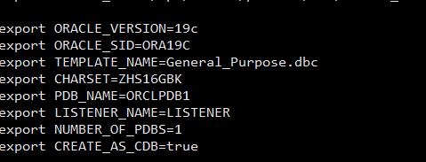

6.2修改数据路径，端口号

c

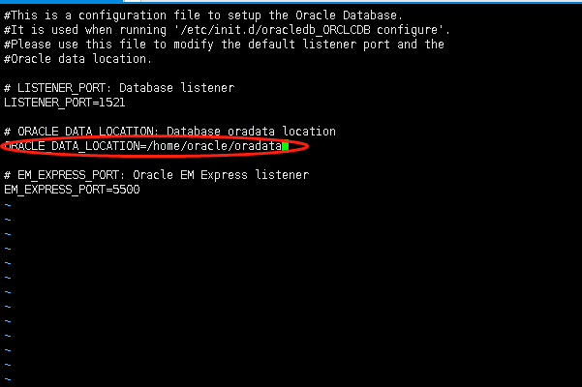

7.使用root用户进行配置.

等待创建成功/etc/init.d/oracledb_ORCLCDB-19c configure

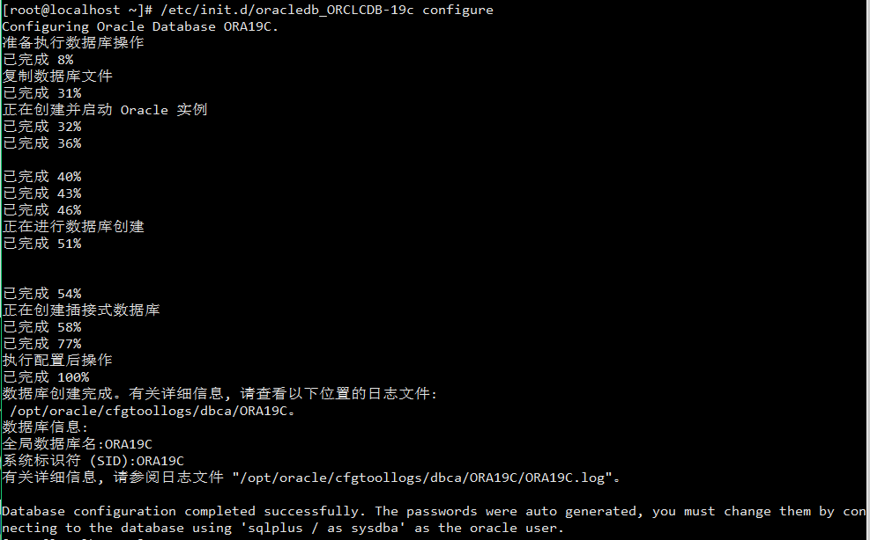

修改Oracle用户的密码

passwd oracle

密码为：aisino123

使用Oracle登录进行相关的处理

su – oracle 进入oracle用户

sqlplus / as sysdba

查看pdb信息

show pdbs

创建自动启动pdb的触发器

CREATE TRIGGER open_all_pdbs AFTER STARTUP ON DATABASE BEGIN EXECUTE IMMEDIATE 'alter pluggable database all open';

END open_all_pdbs;

/

**重新启动容器数据库：**

SQL> shutdown immediate;

Database closed.

Database dismounted.

ORACLE instance shut down.

SQL>

ORACLE instance started.

Total System Global Area 1.4529E+10 bytes

Fixed Size                  7649368 bytes

Variable Size            8489273256 bytes

Database Buffers         5939134464 bytes

Redo Buffers               93011968 bytes

Database mounted.

Database opened.

解决乱码 （设置环境变量）

vi /home/oracle/.bash_profile

export NLS_LANG="AMERICAN_AMERICA.AL32UTF8"

source /home/oracle/.bash_profile

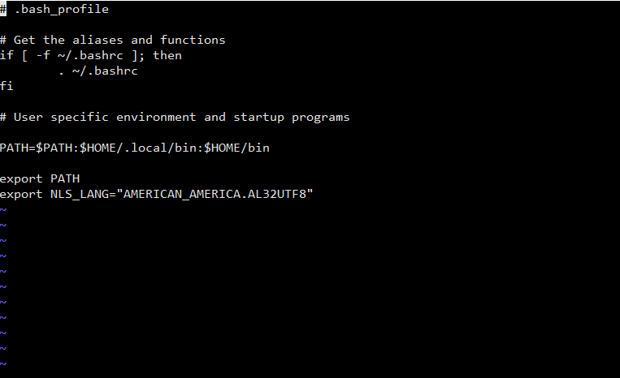

远程连接配置（root权限）

vi /etc/hosts 添加名称

新增本机ip orcdb（ifconfig查询 例如：）

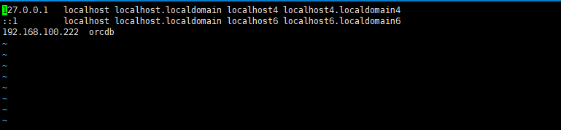

vi /etc/hostname 修改主机名称 为orcdb

编辑:

vi /opt/oracle/product/19c/dbhome_1/network/admin/tnsnames.ora

HOST = orcdb

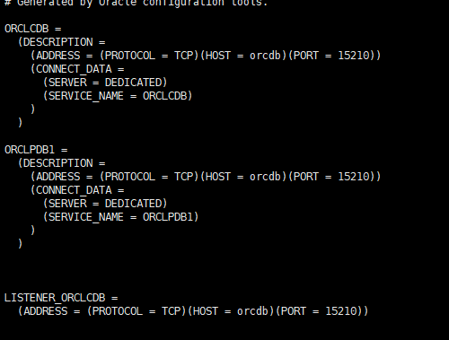

vi /opt/oracle/product/19c/dbhome_1/network/admin/listener.ora

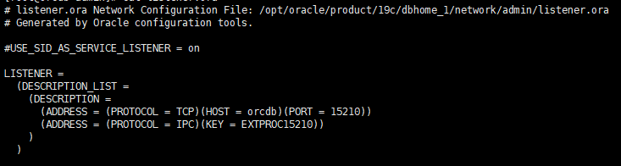

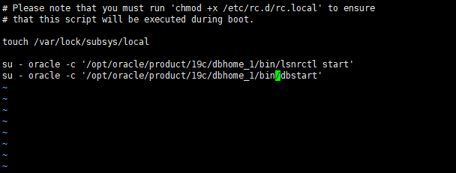

netstat –tpnl（查看监听端口信息）

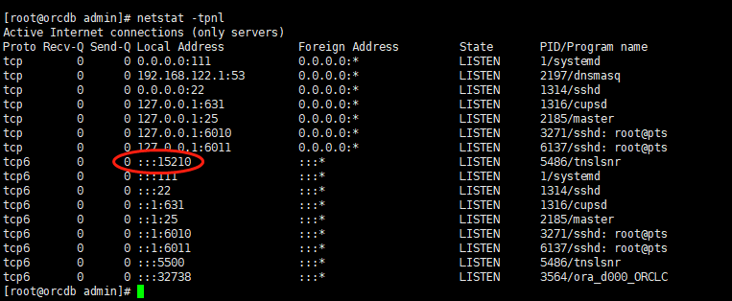

启动监听：lsnrctl start   
查看监听：lsnrctl status   
停止监听：lsnrctl stop

修改密码

alter user dzfp account unlock; //解锁

alter user ykp identified by aisino123; //修改密码

oracle用户下：

cd $ORACLE_HOME/network/admin

vi sqlnet.ora

SQLNET.ALLOWED_LOGON_VERSION=8 //修改文件，解决11g驱动没有匹配的验证协议

系统重启 reboot